H.T No
Regulations:
A18

Sreenidhi Institute of Science and Technology
(An Autonomous Institution)
Code No: 7A304 Date: 02-July-2021(FN)

B.Tech II-Year I-Semester Pending External Examination, July-2021 (Regular&Supplementary)
ELECTRICAL CIRCUITS AND NETWORKS – II (EEE)

Time: 3 Hours Max.Marks:70

Note: a) No additional answer sheets will be provided.
b) All sub-parts of a question must be answered at one place only, otherwise it will not be valued.
c) Missing data can be assumed suitably.

ANSWER ANY 5 OUT OF 8 QUESTIONS. EACH QUESTION CARRIES 14 MARKS.

Bloom's Cognitive Levels of Learning (BCLL)

Remember | L1 | Apply | L3 | Evaluate | L5
Understand | L2 | Analyze | L4 | Create | L6

 |  |  | BCLL | CO(s) | Marks
1. | a) | What is the effect of variation of power factor on the readings of two-watt meters used in 3-phase power measurement? | L1 | CO1 | [7M]
 | b) | Determine the line currents in an unbalanced star connected load supplied from symmetrical three phase 440v system. The branch impedances are  Z_{R} =4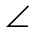30⁰, Z_{Y} =1045⁰ and Z _{B}=1060⁰. The phase sequence is RYB. | L5 | CO1 | [7M]
2. | a) | Analyze DC response of series R-L circuit using Differential approach. | L4 | CO2 | [7M]
 | b) | For the circuit shown in below fig, derive the current equation when the switch is opened at t=0.  100v  –  –  +  +  5 Ω  10 Ω  20 Ω  I  10 I  5 μf | L3 | CO2 | [7M]
3. | a) | Explain the necessary conditions for driving point functions. | L2 | CO3 | [7M]
 | b) | Explain the properties of Transfer functions. | L2 | CO3 | [7M]
4. | a) | Determine Y parameters for the circuit given below.  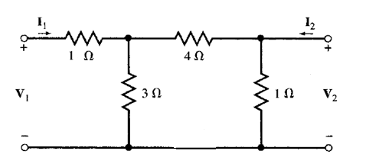 | L3 | CO4 | [7M]
 | b) | Obtain ABCD parameters in terms of Z parameters. | L3 | CO4 | [7M]
5. | a) | Draw the circuit diagram of a low pass filter. Explain the design procedure of the above filter in detail. | L2 | CO5 | [7M]
 | b) | Explain the general configuration and parameters of a high pass filter T and π – Sections. | L2 | CO5 | [7M]
6. | a) | Explain i) Even function symmetry ii) Odd function symmetry. | L2 | CO6 | [7M]
 | b) | Derive the trigonometric Fourier series of following waveform.  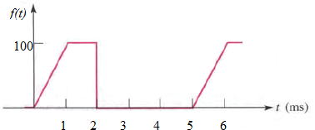 | L3 | CO6 | [7M]
7. | a) | The two watt meter readings in a 3 - phase power measurement are 800W and 400W. The later reading is being obtained after the reversal of current coil. Calculate the total power and power factor of the load. | L3 | CO1 | [5M]
 | b) | Explain the procedure adopted for the evaluation of initial conditions. | L2 | CO2 | [5M]
 | c) | Explain the restrictions of pole zero locations for driving point functions. | L2 | CO3 | [4M]
8. | a) | A typical two port network is characterized by the following equations.  2V₁ + 4I₂ = I₁  V₂ + 6V₁ = 8I₂  Determine the values of Z₂₁, Y₁₂ parameters. | L3 | CO4 | [5M]
 | b) | Write short notes on Band Pass filter. | L1 | CO5 | [5M]
 | c) | Find the Fourier series expression for a symmetrical square wave signal. | L1 | CO6 | [4M]

-- 00 -- 00 –

